# Media Analysis - ChatGPT is the ‘Netscape moment’ for artificial intelligence’ _ Arab News

## Short Summary

The article is about the rapid adoption and impact of large language models LLMs , like ChatGPT, on various industries and society at large.

## Summary

Summary:  
  
1. ChatGPT is compared to Netscape for AI's impact on the web.  
2. The model's strength lies in its rich conversational interface, capturing popular imagination around AI.  
3. While progress has been made in deep learning and understanding context, models still lack common sense and reasoning ability.  
4. Saudi Arabia, with initiatives like the Saudi Data and AI Authority, is well-positioned to leverage AI for future prosperity.  
  
Disclaimers: The summary condenses the key points from the original text. It does not include all the details or the writer's specific views.

## Question 1

Media framing, in the context of discussing ChatGPT, plays a significant role in shaping public perception and discourse. The media often uses metaphors, analogies, and visual representations to convey complex concepts to a wider audience. Some recurring metaphors and frames include 1. **Revolutionary technology** ChatGPT is often portrayed as a breakthrough that disrupts traditional ways of communication or information generation. 2. **Artificial intelligence s next step** Similar to how smartphones evolved from feature phones, ChatGPT is seen as a progression in AI s ability to understand and interact with humans more seamlessly. 3. **Balancing progress and concerns** Media discussions often emphasize the benefits of ChatGPT while also raising concerns about its potential misuse, job displacement, or ethical implications. In summary, media framing of public discussions around ChatGPT often employs metaphors that highlight the technology s transformative nature, while also grappling with the accompanying challenges and uncertainties.

## Question 2

The perspectives and aspects being widely covered in discussions about ChatGPT include 1. Technological innovation How LLMs like GPT work, their potential for automation and augmenting human tasks. 2. Applications across industries Examples of how these models can be integrated into various sectors, from content generation to consulting. 3. Ethical concerns and bias The discussion around the potential for AI-generated content to spread misinformation or perpetuate biases. 4. Business implications and disruption The impact on traditional business models, jobs, and competition from the widespread adoption of AI technologies. However, some aspects that may be receiving less attention include 1. Technical development and infrastructure How these models are being developed, improved, and integrated into existing systems. 2. Progress in foundation models and specialized domain learning The extent to which these models can adapt to specific domains or learn rules and ethics beyond statistical correlations. 3. Regulatory frameworks and standards The discussion around the establishment of legal guidelines and industry standards for AI technologies to ensure responsible use and minimize risks. 4. Collaboration between governments, academia, and private sector The extent to which different stakeholders are working together to promote AI development, share best practices, and address common challenges.

## Question 3

The Arabic World is mentioned as a potential market or context for the application of artificial intelligence AI . However, specific details on how they leverage AI are not provided in the text. So the answer would be Not mentioned .

## Question 4

The final message is that Saudi Arabia should embrace AI to create value, solve national challenges, and ensure future prosperity.

## Sentiment

The sentiment is 3.0

## Entities

the Saudi Data, Disclaimer Views, ANTHONY BUTLER, exempli ed, AI, Aramco, IBM, Anthony Butler, Arab News, GPT, ChatGPT, AI Authority

## Highlights

#7cc867#fb5b89#c885da

## Wordcloud for #7cc867 Highlights

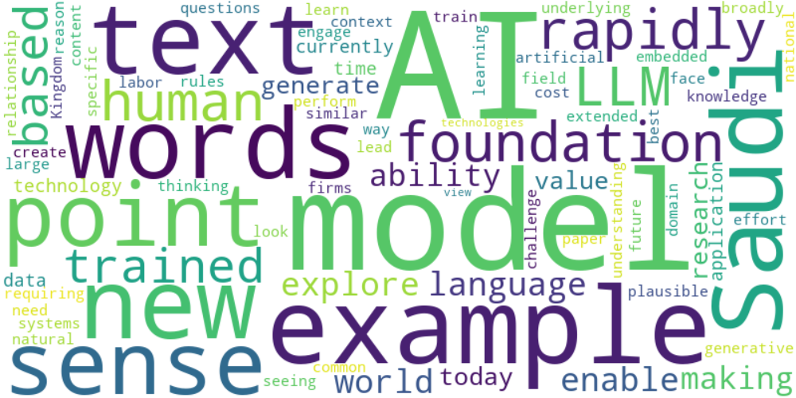

Top 10 words:

- AI: 13

- models: 8

- example: 6

- words: 5

- Saudi: 5

- text: 4

- point: 4

- sense: 4

- like: 4

- rapidly: 4

## Wordcloud for #fb5b89 Highlights

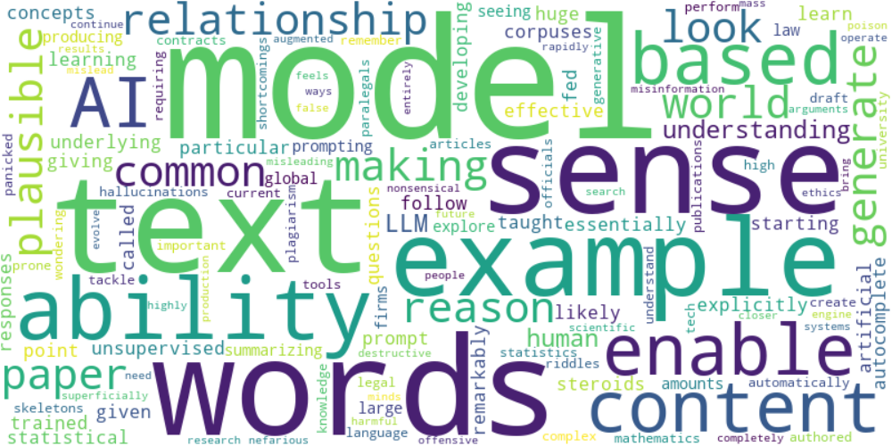

Top 10 words:

- models: 6

- words: 5

- text: 4

- sense: 4

- like: 3

- example: 3

- ability: 3

- model: 2

- content: 2

- based: 2

## Wordcloud for #c885da Highlights

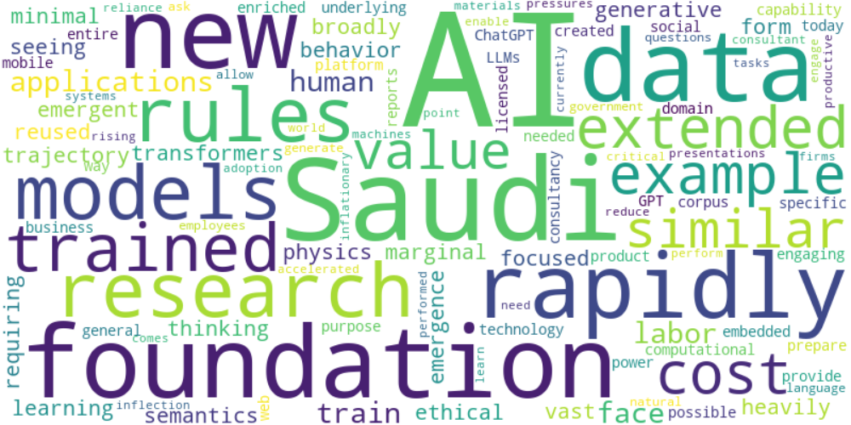

Top 10 words:

- AI: 9

- Saudi: 4

- new: 3

- rapidly: 3

- research: 2

- rules: 2

- foundation: 2

- trained: 2

- extended: 2

- example: 2